Privacy Notice for Occupational Health
Ayrshire College (the College) is providing you with this information to comply with data protection law to ensure that you are fully informed and that we are transparent in how we collect and use your personal data.
Your privacy and trust are very important to us and this Privacy Notice provides essential information about how the College handles your personal data (information) and the rights you have in relation to how we use your data. The College is committed to complying with all applicable Data Protection legislation.
Who are we?
Ayrshire College is the ‘Controller’ and is responsible for looking after the personal data that you provide.
Registered office – Ayr Campus
Dam Park, Ayr
KA8 0EU
For any queries or concerns about how your personal data is being processed you can contact the Data Protection Officer (DPO) at dataprotection@ayrshire.ac.uk
This Privacy Notice relates to the following process: Occupational Health
Purpose for processing – why do we collect information about you?
As your employer we have a duty of care to all of our staff and we collect personal data for the purposes of occupational health (OH) and for the assessment of an individual’s fitness for work staff to carry out their role. We also process staff’s personal data to ensure the health and safety of our staff at work and to allow consideration of any reasonable adjustments that may be required to support their ability to work.
Our lawful basis (reason) for processing your information is:
Use is necessary for the performance of a contract with you or to take steps, at your request, before entering into such a contract.

The data being used includes special category (sensitive) data. Our legal reason for using this sensitive data is:
For the processing of special category personal data (i.e. health data), the lawful basis is: Article 9(2)(h) “Processing is necessary for the purposes of preventive or occupational medicine, for the assessment of the working capacity of the employee, medical diagnosis, the provision of health or social care or treatment or the management of health or social care systems and services on the basis of Union or Member State law or pursuant to contract with a health professional and subject to the conditions and safeguards referred to in paragraph 3”.
Article 9(3) states that processing is permitted “when those data are processed by or under the responsibility of a professional subject to the obligation of professional secrecy.”
All health professionals will adhere to their employers and governing bodies’ professional standards with regards to confidentiality.
Please note any reference to consent is not consent to process personal data under data protection law. Consent is in relation to the Access to Medical Reports Act 1988 (AMRA) only and provides staff with the opportunity to view and correct an OH report prior to it being provided to the employer.
What information do we collect about you?
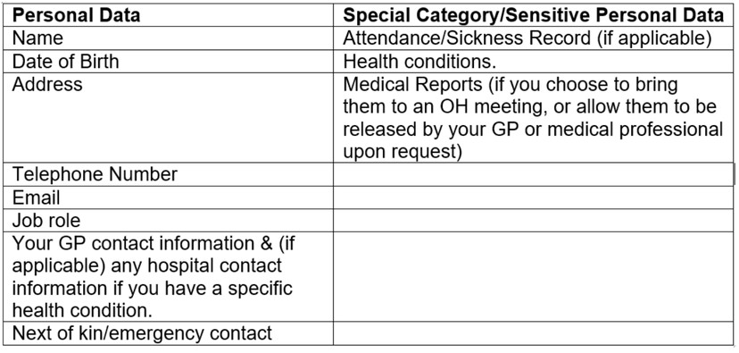

How do we collect it?

We collect your information in a number of ways, depending on the circumstances. The following details are the main ways that data is collected.

Management Referral
When making a referral to our external Occupational Health provider, managers/ HR are asked to confirm that staff have been informed of the details of the referral before submitting. The referral will not be able to go ahead if this is not confirmed with staff.
When we complete an OH Referral Form this requires confirmation that staff have been fully informed of the referral and informed of their rights and, if applicable, their consent under the Access to Medical Reports Act 1988 (AMRA) must be received before an OH assessment and report is carried out. Under AMRA staff have the right to see the OH report before it is sent to their line manager and HR. Under Section 3 of AMRA, medical reports and applications for them are not processed unless the individual has consented. This is consent under AMRA and not under data protection law. Under Section 4 and 5 of AMRA, staff also have rights and can request that inaccurate information is corrected. If the medical professional considers this is accurate, a note on the report will be added to reflect this.
At the time of receiving the report to review, staff are given a time frame for contacting Occupational Health with consent under AMRA to release the report to their employer.

New Employment Health Questionnaires
As an employer, the College has a duty of care to all staff to ensure their health and safety at work and, when applicable, identify and implement any reasonable adjustments required to enable staff to carry out the role. The new employment health screening is a pre-employment condition that successful applicants must satisfactorily complete prior to any formal offer of employment being considered. Therefore, the College requires new staff to complete a health screening questionnaire in order to determine if the individual is fit for work and carry out the tasks that they will be performing and identify any reasonable adjustments that may be required.
You are contractually obliged to provide your information for the purpose of assessing your fitness to work to carry out the role for which you have applied, within the College.
If you were to withhold the information we require for this process, the consequences would be:
We would not be able to progress your pre-employment checks and, therefore, we would not be able to consider further your application for employment with the College.

Health Surveillance
For some roles, health surveillance will need to be undertaken where a risk assessment indicates that an individual might be exposed to certain hazards within the workplace i.e. noise, vibration, dust etc.
Where we have a statutory obligation to conduct health surveillance assessments you are contractually obliged to provide your information and attend health surveillance appointments. This will be required on an annual basis, unless advised otherwise by the Health Surveillance provider.
Following the health surveillance appointment, the College will receive a Health Surveillance Record form which will detail the result of the health surveillance consultation. No sensitive personal information will be included in this record form.
Who do we share your information with?
For the purposes of Management Referrals:
- The OH Report is shared with your line manager and the HR department. However, this is only shared if you have provided your consent under AMRA.
- Management referral information is collected and held by our external Occupational Health provider - Optima Health.
For the purposes of New Employment Health Screening:
- A report is provided for the College’s HR department to ensure that, as appropriate, reasonable adjustments and support can be provided.
For the purposes of Health Surveillance:
- For the purpose of skin surveillance only, your Screening Questionnaire will be checked by a trained ‘Responsible person’ from the Health, Safety & Wellbeing Team. If further investigation is required, your questionnaire will be shared with Salus, Occupational Health, Safety & Return to Work Services.
- The Health Surveillance Record form is shared with the College’s HR department, Health, Safety and Wellbeing department and your line manager, where necessary.
For the purpose of New Employment Health Questionnaires and Health Surveillance assessments:
- Your information is collected and held by our current external provider – Salus, Occupational Health, Safety & Return to Work Services.
Details of data transfers to any third countries or international organisations
Your information will not be shared outside of the UK.
How do we look after your information and how long do we keep it for?
We will take all reasonable steps to prevent the loss, misuse or alteration of information you give us. Your personal information will be stored securely and will only be accessed by authorised staff, agents, contractors and other organisations who have a business need to know. They will only process your personal information on our instructions, and they are subject to a duty of confidentiality and must comply with data protection law.
We have put in place procedures to deal with any suspected data security breach and will notify you and any applicable regulator of a suspected breach where we are legally required to do so.
Retention:
Occupational Health records will be kept by the College for the length of employment and for 7 years after leaving employment (this applies to Management Referrals and New Employment Health Questionnaires). Once this retention period has passed, these records will be destroyed securely following College procedures.
For health surveillance records, these are required under The Control of Substances
Hazardous to Health Regulations (COSHH) 2002 and the related Health and Safety at Work Act 1974 which require that records are kept for 40 years. Following this time period, the records will be destroyed securely in line with College procedures.
Automated individual decision-making processes, including profiling.
We do not use any automated decision-making about you for this process.
Your rights
Under Data Protection legislation you have certain rights in relation to how the College manages and uses your personal information:
- The right to be informed (this is the Privacy Notice)
- The right to access your personal data
- The right to rectification if the personal data we hold about you is incorrect
- The right to restrict processing of your personal data

In addition, the following rights apply only in certain circumstances:
- The right to withdraw consent at any time (if consent is our lawful basis for processing your data)
- The right to object to our processing of your personal data
- The right to request erasure (deletion) of your personal data
- The right to data portability
- The right not to be subject to automated decision making including profiling.
For more information about your rights please see www.ico.org.uk.
Contact us
If you have any issues about this notice or the way the College has handled your personal information, please contact our Data Protection Officer in the first instance:
email: dataprotection@ayrshire.ac.uk
Telephone: 0300 303 0303 or write to:
Data Protection Officer
Ayrshire College, Kilmarnock Campus
Hill Street
Kilmarnock
KA1 3HY
Complaints to UK Information Commissioner’s Office (ICO)
If you are dissatisfied with the response from the College, you have the right to lodge a complaint with the Information Commissioner’s Office (ICO) about our handling of your data:
Email: Contact us - public | ICO
Telephone: 0303 123 1113 or write to:
Information Commissioner’s Office
Wycliffe House
Water Lane
Wilmslow
Cheshire
SK9 5AF
April 2026

